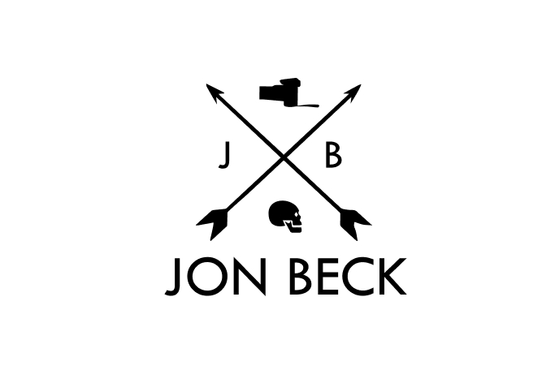
About your organisation
1. Provide a description of your organisation/brand and your industry
Jon Beck is an international award-winning photographer, specializing in fine art, portraits, landscape and building photography. Jon’s approach to his work is one of no compromise, from image capture, printing and framing he uses only the finest quality materials available. Jon’s stunning art pieces decorate the walls of many homes, offices and commercial spaces around Australia and the world.
“I am drawn to the diversity of the world – from Australia’s red soil centre, the character in peoples faces and the unique textures of our building heritage. My combined passion for the outdoors , people and their environment enables me to create iconic images from Australia’s diverse landscape, New Zealand and the world.I believe photograph’s have to provoke an emotion, represent uniqueness and tell a story.”
Living in Queensland, he is surrounded by beautiful beaches, the unique characters of its people and ideal weather; which Jon uses for inspiration to create his stunning images. Jon constantly strives to capture spectacular light and mood within his images, while maintaining a fresh hipster perspective. He believes a photograph has to provoke an emotion, represent the landscape and tell a story- but with a difference.

1.1 Who are the primary contacts from your organization, and who has final approval on the project? Please list names, titles, email addresses, and phone numbers.
Jon Beck Art Director
EMAIL : info@JBphotography.com
Office: Level 1, 265 Pittwater Road Nowhere 2100
PHONE : 0411 132 843
1.2 Do you have a specific budget range already established for this project?
I don’t have any money for images or photographers or anything- you must use the images that I provide only.
2. List some web sites of similar service providers and list what you like about that site?
A1. Web site address -- https://christinahohner.de/
A2. What do you like about this web site 1– nice use of layouts, good use of colour and typography, professional and interesting.
B1. Web site address -- https://yazzenphotography.com.au/
B2. What do you like about this web site– has personality, nice use of typography, nice use of images, layout is a bit cluttered with animation

3. List some sites you hate, and why?
A1. Web site address -- http://www.nicolastarierphotography.com/
A2. What do you hate about this web site –too cluttered, impossible to navigate, all the same – a one trick pony, just a lot of nameless images
B1. Web site address -- https://www.petermckinnon.com/
B2. What do you hate about this web site –who is this person and what do they do?, no meaningful tagline, too cluttered, random dull images

4. What is the purpose of this site? (e.g., to promote the service, customer service, dissemination of knowledge) Please describe in detail.
We are primarily interested in promoting our work and selling photographs. We also run training workshops with photographers. Most photography websites are either cluttered or have very simple tables of nameless images. Although I like the minimal aesthetic we need something different that will set us apart. Jon Beck Photography is a high end production company so we need to be distinct. We focus on understanding the specific needs of our clients, and provide a high level of personal service. We are industry professionals with a clear focus on client responsiveness and project delivery- with distinctive flair where “every photo tells a story- but with a difference” as our founding philosophy. Using the latest technology and implementing best practice solutions is crucial to ensuring we achieve the best outcomes for our clients.
Our business goals are to
- Increase market share by generating awareness and showcasing our work
- Increase traffic and sales through the website
- Increase total income through increased sales, driven by high-quality products and innovative product and service offerings.
- maintain customer loyalty through exceptional customer service
5. Do you have any existing marketing/PR campaign material in digital format? And do you want the website to tie in with any existing marketing materials/ logos?
I have a logo
6. Who is the primary audience?
1. What are the interests of the target audience?
Mums and Dads who want to spoil themselves to high flying corporate and fashion clients, willing to spend money on quality photography,
2. What do they find appealing?
Good images that show a unique point of view that captures with emotion
3. How long do you think a typical audience member may been using the net?
Most are professionals and use it as part of their business and everyday life
4. What is their average income level? 60,000- 100+
5. What is their average age? 35-50yr

7. What is a typical task the visitor might perform on the new site?
Look at photos, call or email for more information/ quote, buy some photos,
8. Where will content for the site come from? Will it be newly created, re-purposed or both? Do you have all the content (text, images, video) for the website ready to be used??
I will provide all copy- see below, you have to use these images only
9. If you were a user what search words might you use to locate the site on Google/Yahoo?
Jon Beck Photographer for COMMERCIAL, PORTRAITS, FASHION, ADVERTISING, JB Photography
10. Emotional reaction considerations--Describe the typical user reaction/first impression you would want from your clientele;
Typical user reaction to the company/organisation represented
Exclusive without alienating, something different with character, distinctive from other photographers, sophisticated, quality, user friendly,
Typical user reaction to the content of the front page
Cool, Overall style reflects quality, exclusive
Typical user reaction to time spent on the site
Professional, Feel confident in service offered, quality offered

SOME INFO ABOUT US
ABOUT JON BECK
Jon Beck has been working in the Photography industry for over 15years. Jon is a professional photographer who combines precise technical skills with an approachable and personable demeanour to help you achieve your vision.
Jon's pictures are not souvenirs, but images that help us to ‘see’ and to understand landscapes and people as art. Light literally exudes from Jon’s pictures like few others, and this luminescent enlightenment startles us with its clarity and perception

With a wide knowledge of photographic skills, Jon photographs many subjects beyond his portfolio that is seen online. You can keep up to date with Jon’s latest projects through Facebook, Twitter and Instagram.

Photography Workshops & Tours
Looking to improve your photography?
Workshops are a fantastic opportunity to learn while joining Jon on an adventure to some of the world's most breathtaking locations. Having had the privilege of shooting in so many exotic regions, Jon's knowledge will guide you to spectacular locations, while experiencing a unique insight into his photographic process and digital workflow.

Wild Tasmania - 5 Day Photography Tour
** Limited Spots Remaining **
Dates: 23 - 27 March 2030
Limited to 6-8 participants
Price: $1150
Character of Ballarat- 5 Day Photography Tour
** Limited Spots Remaining **
Dates: 2 - 17 August 2030
Limited to 6-8 participants
Price: $1150
Sydney Seascapes - 1 Day Photography Tour
** SOLD OUT **
Dates: 6th July 2030
Location: Sydney, Australia
Limited to 4-6 participants only

Print Information
Individually produced to the highest possible standards Jon Beck’s limited edition prints are printed on world leading photographic paper. Fujiflex Crystal Archive. Fujiflex is an ultra high gloss, museum grade photographic paper, with archival properties of over 40 years. Hand signed, titled and numbered by Jon these prints are printed in editions of only 50, 100 or 250. When each 10% of an edition sells the prices then increase by a further 20% making them an excellent investment.
Limited Editions
A Limited Edition Print is a print that will only be made a certain number of times. This means that only a set number of prints, regardless of their size, will ever be produced for each image. As an edition sells, the price of the print increases. Once an edition is sold out, no more limited edition prints of the image will be made. Ever. Each print is hand-signed, registered and comes with a Certificate of Authenticity.
Museum-Grade Framing
Each frame is custom made to order by our specialist-framing studio, using museum-grade materials and matboard to give every print the best possible archival properties. All framed prints come finished with Museum Quality Conservation Acrylic (Perspex), the highest standard for artworks, eliminating harmful UV rays to provide maximum protection for your print, protecting against dust, humidity and condensation. Limited Edition Prints 30" and over, are expertly mounted and sealed onto treated Aluminium ensuring the maximum longevity of the artwork. Limited Edition Prints under 30" are mounted onto MDF board using acid-free materials, providing a more affordable option for customers that aren't too concerned about the archival life of the finished product.
Worldwide Shipping
All unframed Limited Edition Prints include FREE shipping worldwide. Our prints are individually printed to order and each one is a registered, signed and numbered masterpiece. Every Limited Edition Print has to be inspected and so some delays can occur when working around our busy travel schedule. Framed prints are delivered approximately 4-6 weeks from the date payment is received. Unframed prints are delivered in approximately 2-3 weeks.
Packaging
Every framed print is professionally packaged to prevent damage during transit. In the unlikely event that damage should occur during transit, we aim to resolve any problem quickly and to your complete satisfaction.

